Presentation structure

- Title & context
- Digital Humanities Framework
- Problem & motivation
- Research aim & question
- Methodological Framework
- Contribution
- Data & methods
- Analytical pipeline
- Key findings (quant + NLP)
- Word clouds
- Workflow selection
- Redesign strategy
- Students Mobile - Before State
- Students Mobile - After State
- Student Desktop - Before State
- Student Desktop- After state
- Admin - Before State
- Admin - After state
- Before/after comparison (steps)
- Prototype wiring
- Prototype testing results
- Style Guide
- Mobile Hi-Fi screens
- Implications
- Conclusion
- Future work
- QR / repository / thank you

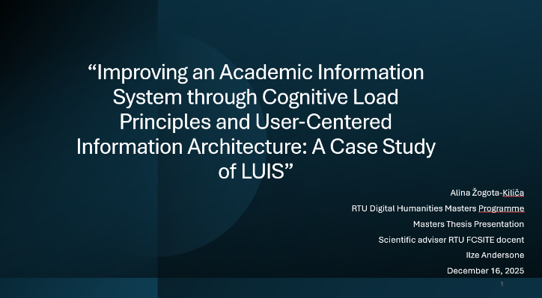

Title slide
“Today I’ll present my master’s thesis on usability in Latvian academic information systems, using LUIS as a case study.
I examine how workflow structure, navigation, and terminology create unnecessary mental effort, and how user-centered information architecture can reduce it.
I’ll briefly present the method, the key findings from user data, and how the redesigned workflows performed in prototype testing.”

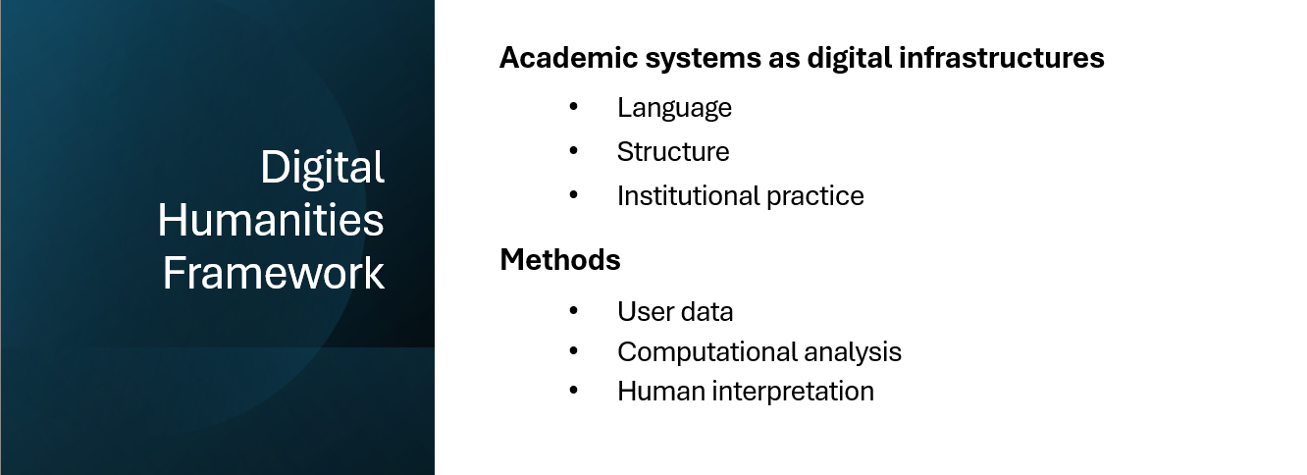

DH Framework
“From a Digital Humanities perspective, this thesis treats academic information systems as digital infrastructures shaped by language, structure, and institutional practice, studied through user data with computational support.”

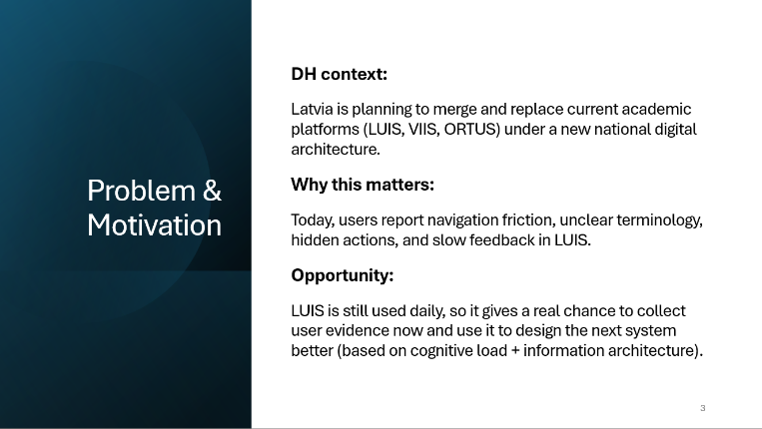

Problem & Motivation
“Latvia is planning a major digital change. Systems like LUIS will be merged or replaced by one national platform, and the design choices made now will affect users for years.
LUIS is still used every day, which gives a clear opportunity to observe real user behavior and see where students and staff lose time or get stuck, before these problems are carried over into the next system.
What users struggle with is not academic logic. They usually know what they want to do. The problem is the interface, and this creates unnecessary mental effort.
So, the motivation of this thesis is practical: to use evidence from LUIS to guide clearer information architecture and workflow design for future academic platforms.”

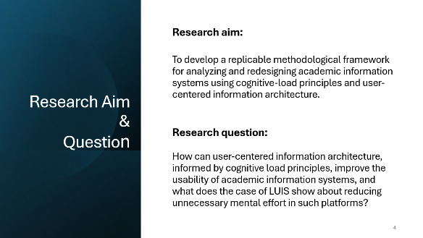

Research Aim & Research Question
“The aim of this research is to develop a reusable method for analyzing and improving academic workflows using cognitive-load principles and user-centered information architecture.
I combine cognitive load theory with information architecture to identify where interfaces add unnecessary effort and translate those findings into concrete redesign decisions.
LUIS serves as the case study because it has real daily users and well-defined workflow problems.
The research question is: how can user-centered information architecture, informed by cognitive-load principles, improve usability in academic information systems, and what does LUIS show about reducing unnecessary mental effort?”
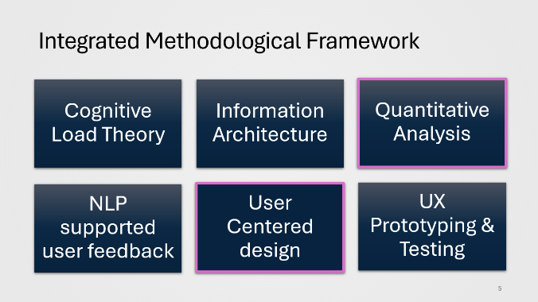

Methodological Framework
This slide shows the integrated methodological framework.
- Cognitive Load Theory separates task difficulty from interface-caused effort.
- Information Architecture addressed structure, navigation, and labeling.
- User-centered design grounds the work in real workflows.
- Surveys and NLP identify high-impact problems to address.
- Finally, prototyping and testing validate if the redesigned workflows feel clearer and require less mental effort.
Overall, the framework moves from user evidence to workflow redesign and then to user validation.

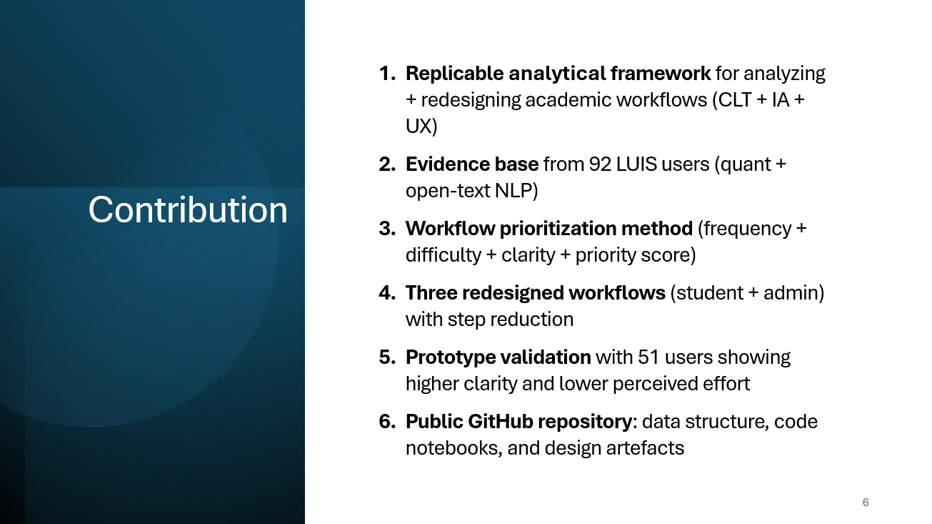

Contribution
This thesis contributes a reusable, data-driven framework for analyzing and redesigning academic workflows using cognitive load theory and information architecture.
It is supported by evidence from real LUIS users, including open-text feedback structured with NLP, and a practical method for prioritizing high-impact workflows. The framework is demonstrated through redesigned student and administrative workflows with measurable step reduction and validated through prototype testing with 51 users.
All data, code notebooks, and design artefacts are available in a public GitHub repository.
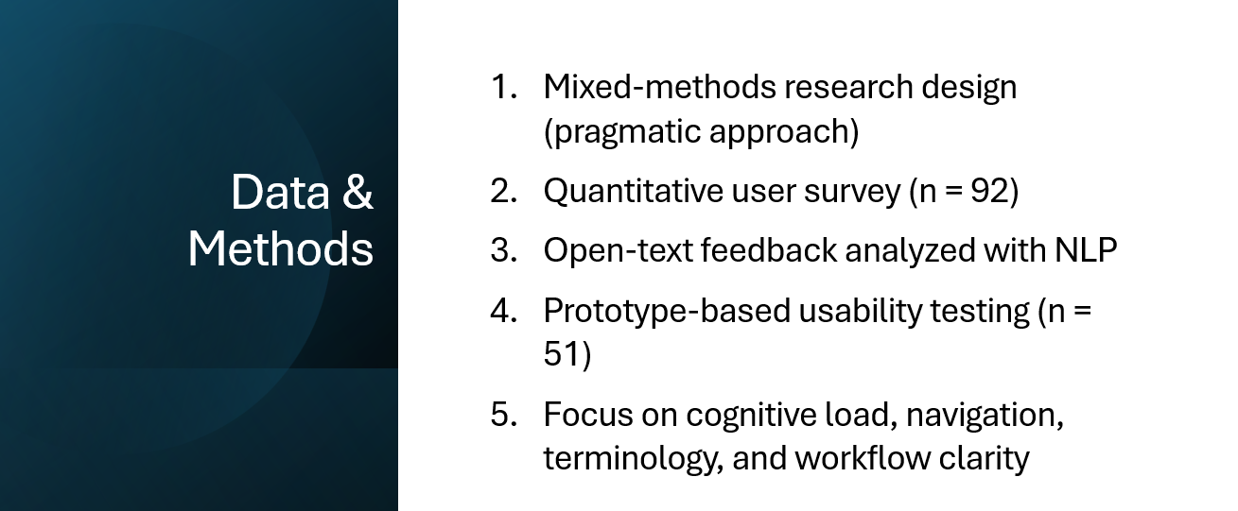

Data & methods
“This research uses a mixed-methods design, combining quantitative data and written user feedback.
I conducted a survey with 92 active LUIS users, focusing on task difficulty, clarity, mental effort, and device use. Open-text comments were analyzed with basic NLP to structure recurring themes beyond numeric scores. The redesigned workflows were then tested with 51 users using clickable prototypes.
Data was used to identify where users struggle, not to automate fixes, but to inform clearer structure and workflow redesign.”

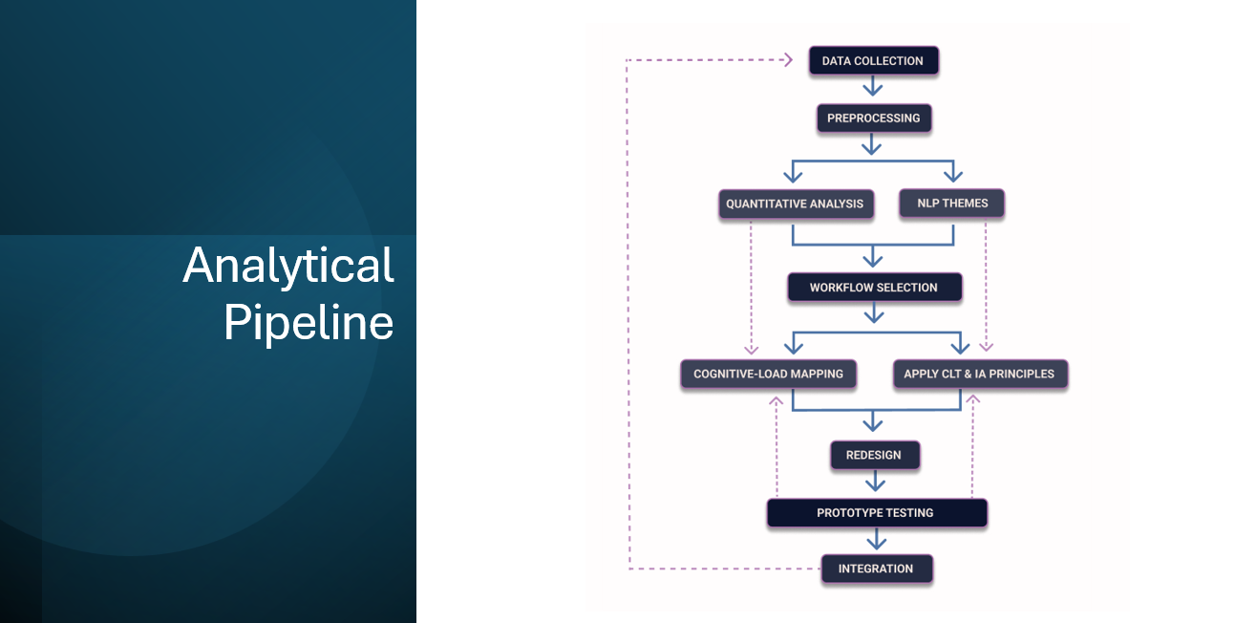

Analytical Pipeline
“This slide shows the full analytical pipeline used in the thesis.
User feedback is collected and prepared for analysis. Quantitative results show where effort and friction concentrate, while NLP structures open-text comments to explain why those problems occur.
Both signals are combined to select high-impact workflows. These are analyzed using cognitive load theory, focusing on intrinsic versus extraneous load, and redesigned using information architecture principles.
The redesigned workflows are then tested with users, and the results feed back into the framework, making the process iterative and reusable.”
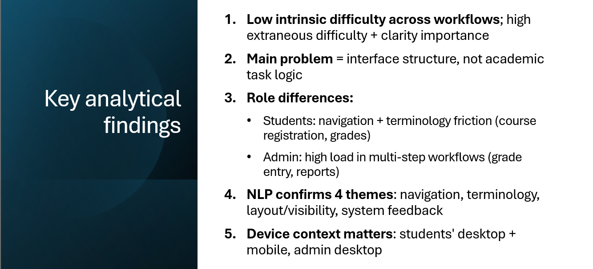

Key findings (quant + NLP)
“The analysis shows low intrinsic task difficulty but consistently high extraneous load across workflows.
The main issue is interface structure, not task logic. Students struggle with navigation and terminology, while administrators face high load in multi-step workflows.
NLP confirms four recurring themes: navigation, terminology, layout and visibility, and system feedback
Device context also matters: students use both desktop and mobile, while administrative work is almost entirely desktop based.”

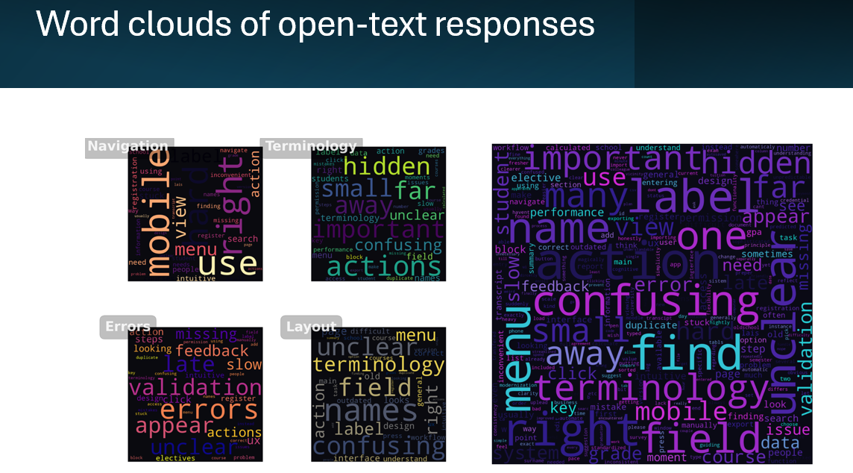

Word cloud of theme specific open-text responses
“These word clouds visualize the open-text responses. They reinforce the quantitative findings by showing the same recurring issues across user comments.”
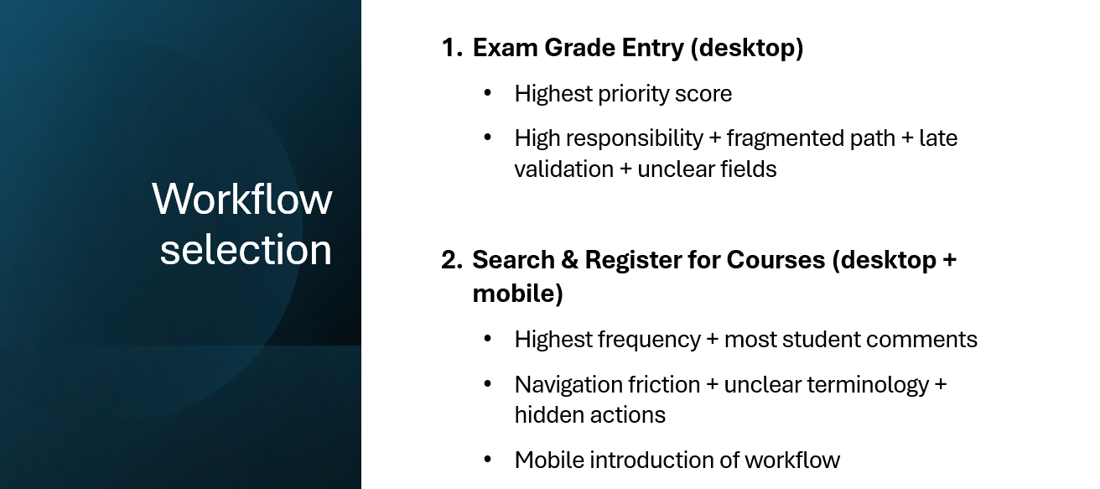

Workflow selection
“Two workflows were selected based on combined quantitative and qualitative signals.
Exam grade entry had the highest priority for administrators, while Course Search and Registration showed the highest frequency and confusion for students, especially on mobile.
These workflows represent the strongest usability problems.”
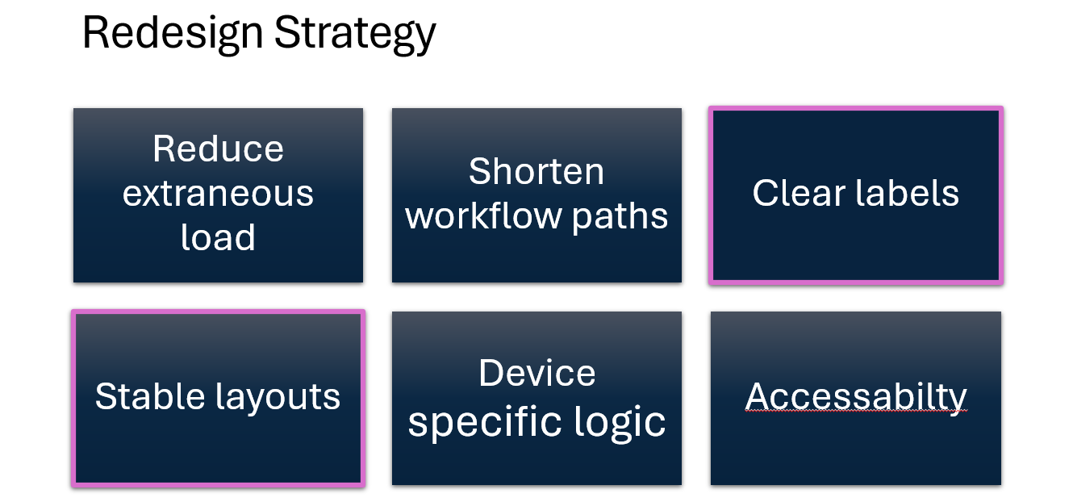

Redesign strategy
“The redesign strategy targets extraneous cognitive load identified in the analysis. Workflows are shortened by removing unnecessary steps and deep menu paths.
Labels and terminology are clarified, and layouts are kept stable and predictable.
The design adapts to device context, with simplified one-column layouts on mobile and clearer overviews on desktop.
Basic accessibility principles are applied throughout.
These rules translate the analytical findings into concrete design decisions across all redesigned workflows.”

Students Mobile – Before State
“Moving to examples. On mobile workflows existing state, key student actions like course registration are not visible on the main screens, which makes the workflow unusable without switching to desktop.”

Students Mobile – After State
Here, the redesigned mobile flow makes course registration visible and usable, with one clear path and immediate feedback.

Student Desktop – Before State
On student’s desktop before state, course registration is fragmented across menus, with unclear labels and actions placed far from the task.

Student Desktop – After State
The redesigned student desktop view keeps all course information and actions in one place, making the workflow predictable and easier to scan.

Admin – Before State
The existing admin workflow is long and visually overloaded, with repeated filters, dense tables, and late validation messages.

Admin – After State
Here, the redesigned admin workflow reduces steps, groups related actions, and gives feedback earlier, lowering mental effort and error risk.

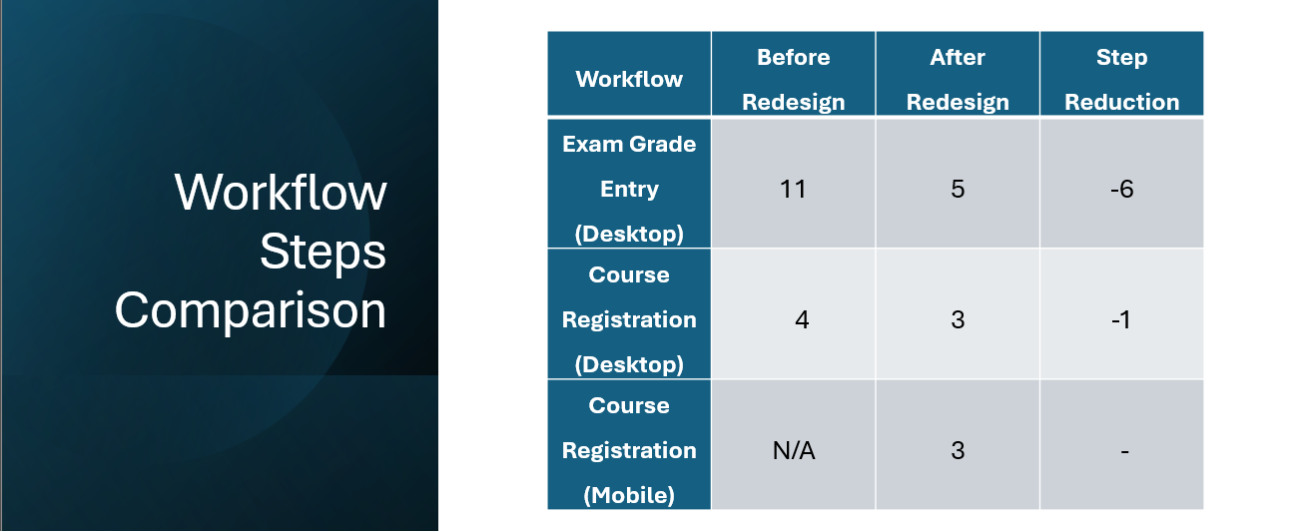

Before/after comparison (steps)
“This table compares the number of interaction steps before and after redesign. The biggest improvement is in admin grade entry, where the workflow drops from eleven steps to five. For students on desktop, the step count changes only slightly, but clarity and visibility improve. On mobile, course registration did not exist before, so the redesign introduces a new, functional three-step workflow.”

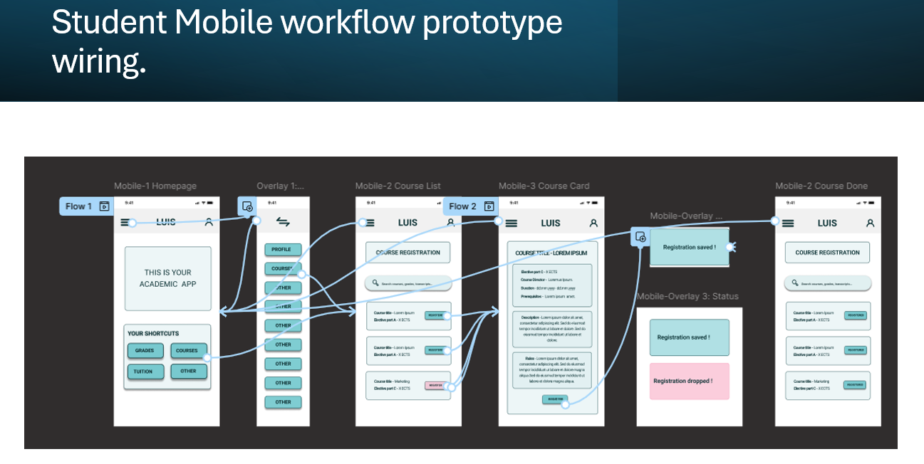

Prototype Testing
“Here you can see an example of the interactive prototype wiring used for testing. I tested the redesigned workflows with 51 users from the original survey group.”

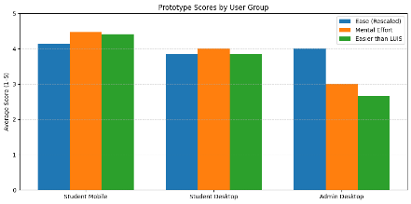

Prototype Testing Results
“Across all user groups, the redesigned prototypes were rated clearer and required less mental effort than the current LUIS. The strongest improvement appears in the student mobile workflow, which aligns with where the original usability problems were most pronounced. This shows that improving structure, navigation, and information layout already produces measurable usability gains, even without full system implementation.
From a Digital Humanities perspective, this demonstrates how user behavior data can directly inform the redesign of institutional digital infrastructure.”
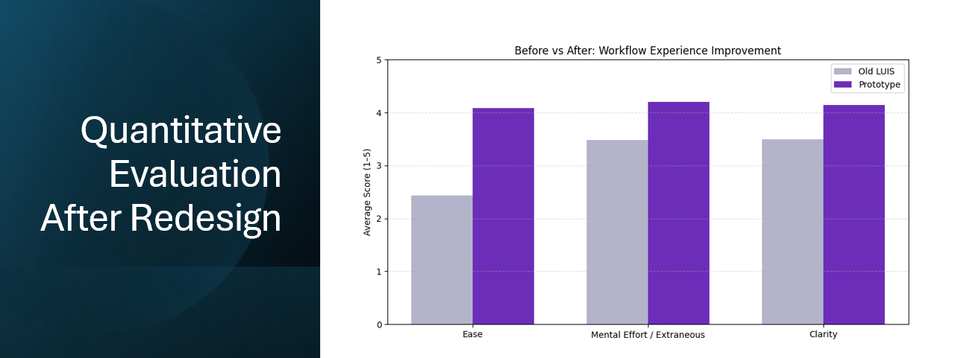

Quantitative Evaluation After Redesign
“And here I show the quantitative evaluation after redesign.
Compared to the original LUIS workflows, the prototypes score higher on ease, clarity, and perceived mental effort. The largest improvement is in extraneous cognitive load, which increases by a wide margin.
This confirms the core finding of the thesis: the main usability barrier is interface structure, not task logic. Even without full implementation, improving information architecture already produces measurable usability gains.”
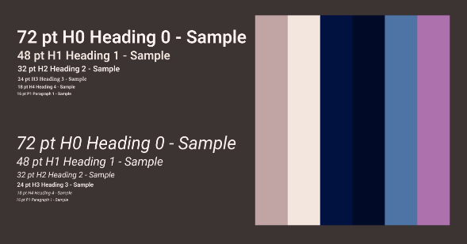

Style Guide
“Here is my proposed style guide that translates the analytical findings into concrete visual rules, such as clear hierarchy, accessible color contrast, and consistent spacing. Its role is to support information structure and reduce unnecessary cognitive load across workflows.”
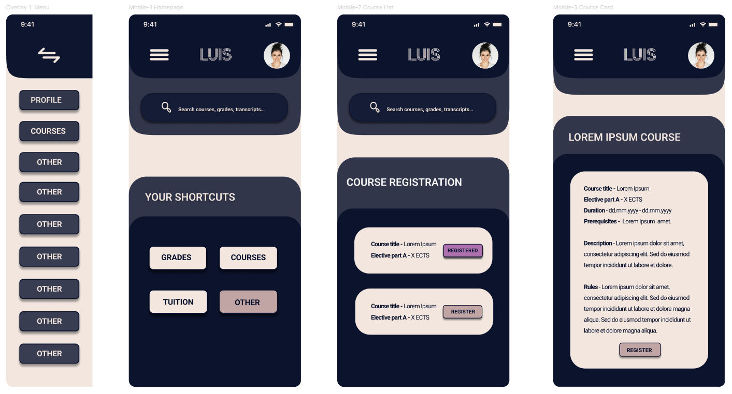

Mobile Hi-Fi Screens
“These high-fidelity mobile screen proposals show how the redesigned workflow could look in practice, using the same structure, hierarchy, and clarity tested in the prototypes.”

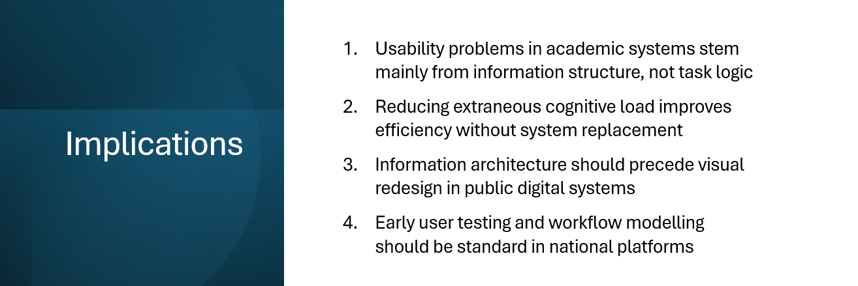

Implications
“From a Digital Humanities perspective, these findings show that usability problems in academic systems are not isolated technical issues, but structural properties of digital public platforms that shape everyday academic work.
This means that information structure, cognitive load, and workflow design should be treated as institutional design decisions, not post-implementation refinements.”
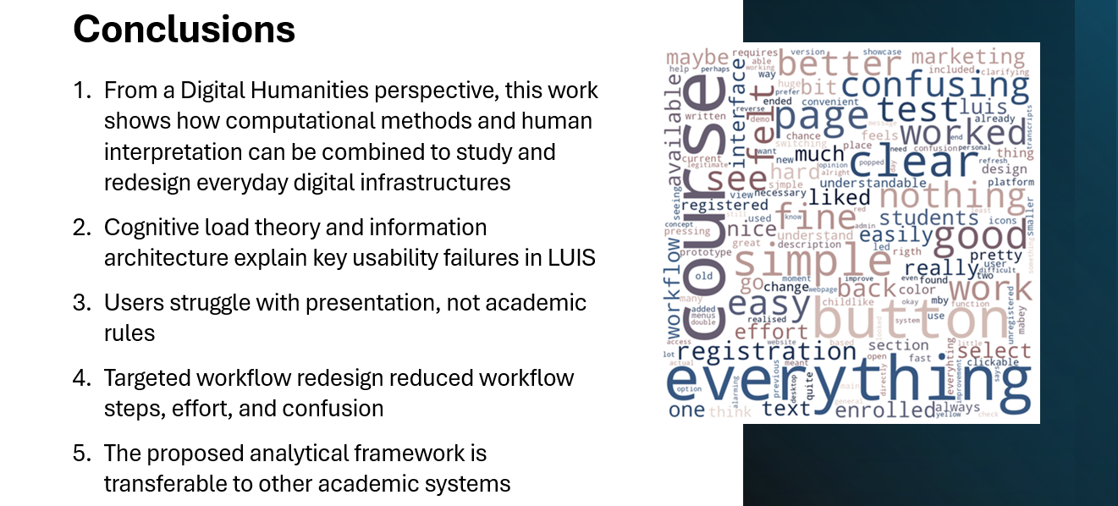

Conclusion
“The case of LUIS shows that many usability problems in academic systems are structural rather than functional. By applying cognitive load principles and information architecture, it is possible to reduce mental effort and improve clarity without rebuilding the system.
From a Digital Humanities perspective, this demonstrates how computational methods and human interpretation can be combined to analyze and redesign everyday digital infrastructures in a grounded, evidence-based way.”
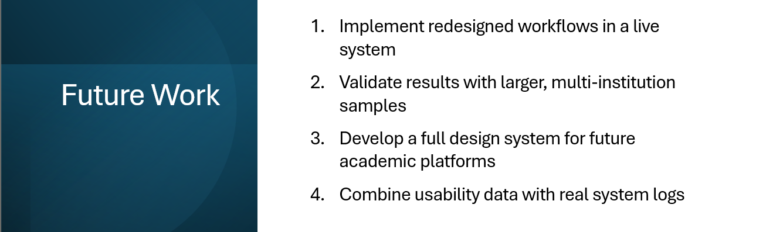

Future Work
“Future work would involve implementing the redesigned workflows in a live system, validating the approach with larger and multi-institutional samples, and combining usability data with real system logs.

These steps would allow the framework to be tested at scale and under real operational conditions.”

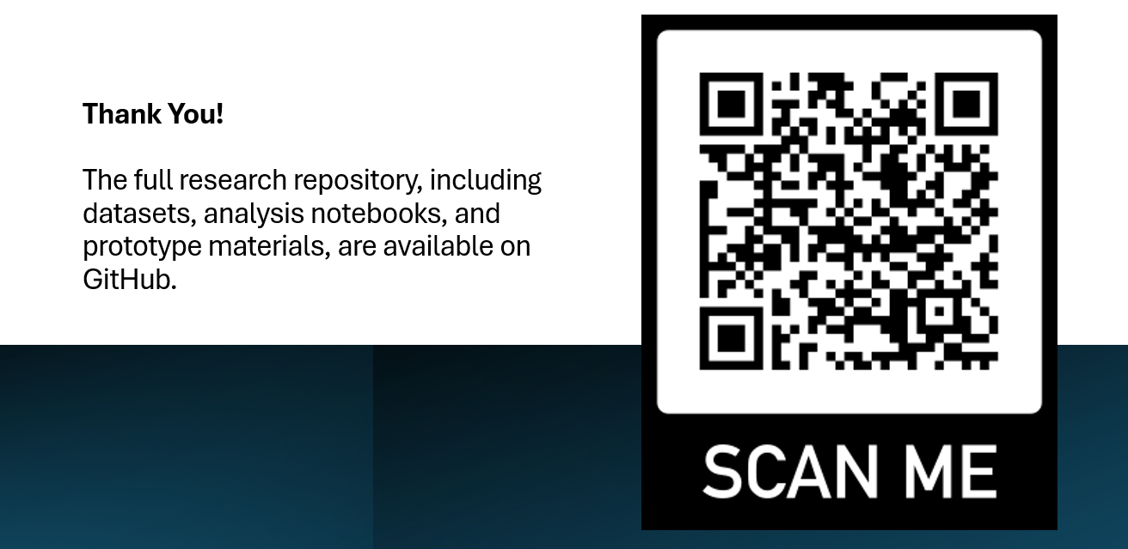

End Slide
“The QR code links to the complete research repository on GitHub. Thank you!”

